ตรา
มหา’ลัย

รายงานการวิเคราะห์
เรื่อง วิเคราะห์................................

................................(ชื่อผู้เขียน)

คณะ.......................
มหาวิทยาลัย.............................
คำนำ
................................................................................................................................................................................................................................................................................................................................................................................................................................................................................................................................................................................

นิยามของ “ผลงานวิเคราะห์” หมายถึง การจำแนก แยกแยะองค์ประกอบของสิ่งหนึ่งสิ่งใดออกเป็นส่วนๆ เพื่อค้นหาว่า มาจากอะไร เชื่อมโยงสัมพันธ์กันอย่างไร?
จากคำนิยาม ถ้าวิเคราะห์ขนมหม้อแกงมีองค์ประกอบเป็นอะไรบ้าง จะพบว่า..ประกอบไปด้วย
แป้ง – ไข่ – กะทิ – น้ำตาล

สารบัญ
หน้า
บทที่ 1 บทนำ xx
ความเป็นมาและความสำคัญ xx
วัตถุประสงค์ xx
ประโยชน์ที่คาดว่าจะได้รับ xx
ขอบเขตของการวิเคราะห์ xx
คำจำกัดความเบื้องต้น xx
บทที่ 2 แนวคิด ทฤษฎี และงานวิเคราะห์/วิจัยที่เกี่ยวข้อง xx
แนวคิด ทฤษฎี xx
งานวิเคราะห์/วิจัยที่เกี่ยวข้อง xx
บทที่ 3 วิธีการวิเคราะห์ xx
ขั้นตอนการดำเนินงาน xx
ประชากรและกลุ่มตัวอย่าง xx
การเก็บรวบรวมข้อมูล xx
การวิเคราะห์ข้อมูลและการนำเสนอ xx
เทคนิคที่นำมาใช้การวิเคราะห์ xx
สถิติที่ใช้ในการวิเคราะห์ข้อมูล xx
บทที่ 4 ผลการวิเคราะห์ xx
......................... xx
........................ xx

หน้า
บทที่ 5 สรุป และข้อเสนอแนะ xx
สรุป xx
ข้อเสนอแนะ xx
บรรณานุกรม xx
ภาคผนวก xx
ประวัติผู้เขียน xx

บทที่ 1
บทนำ
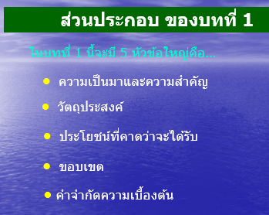
ความเป็นมาและความสำคัญ
................................................................................................................................
.............................................................................................................................................
............................................................................................................................................. ............................................................................................................................................. ........................................................ ..................................................................................... ............................................................................................................................................. ............................................................................................................................................. ............................................................................................................................................. ............................................................................................................................................. ............................................................................................................................................. .............................................................................................................................................
ย่อหน้าแรก
เล่า ความเป็นมา
...................... ..........................................................................................................
.............................................................................................................................................
........................................................ ..................................................................................... ............................................................................................................................................. ............................................................................................................................................. ............................................................................................................................................. ............................................................................................................................................. ............................................................................................................................................. .............................................................................................................................................
ย่อหน้าสอง
เล่า ความสำคัญ
จากความเป็นมาและความสำคัญดังกล่าว ผู้เขียนจึงมีความสนในเขียนผลงานการ
วิเคราะห์ เรื่อง ..................................................................................................(ระบุ)
วัตถุประสงค์
เพื่อ.....(ตามด้วยชื่อเรื่องของผลงานวิเคราะห์)..................................................................
..........................................................................................................................
ประโยชน์ที่คาดว่าจะได้รับ
ได้.......................................................................................... (ลบเพื่อทิ้งได้ประโยชน์)
..........................................................................................................................
ขอบเขตของการวิเคราะห์
ระบุเฉพาะเจาะจง
และ ปี(งบประมาณ/การศึกษา)
...................................................................................................................................................................................................................................................................... .............................................................................................................................................
คำจำกัดความเบื้องต้น
XXX หมายถึง ................................................................................................................
....................................................................................................
YYY หมายถึง ................................................................................................................
....................................................................................................
ZZZ หมายถึง ................................................................................................................
....................................................................................................
บทที่ 2
แนวคิด ทฤษฎี และงานวิเคราะห์/วิจัยที่เกี่ยวข้อง
............ ....................................................................................................................
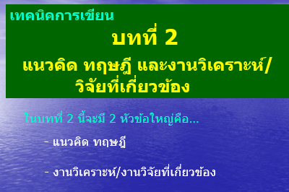
เกริ่นนำ
.............................................................................................................................................
แนวคิด ทฤษฎี
แนวคิด ทฤษฎี A ..................................................................................................
.............................................................................................................................................
............................................................................................................................................. ............................................................................................................................................. .............................................................................................................................................
แนวคิด ทฤษฎี B ..................................................................................................
.............................................................................................................................................
............................................................................................................................................. ............................................................................................................................................. .............................................................................................................................................
แนวคิด ทฤษฎี C ..................................................................................................
.............................................................................................................................................
............................................................................................................................................. ............................................................................................................................................. .............................................................................................................................................

งานวิเคราะห์/วิจัยที่เกี่ยวข้อง
งานวิเคราะห์/วิจัยที่เกี่ยวข้อง A.........................................................................
.............................................................................................................................................
............................................................................................................................................. ............................................................................................................................................. .............................................................................................................................................
.............................................................................................................................................
.............................................................................................................................................
ในการเขียนงานวิเคราะห์/วิจัย ที่เกี่ยวข้องนั้น ก่อนอื่นเราต้องย่อเอกสารเอาไว้ก่อนเล่มนั้นๆ โดยในการย่อนั้น จะต้องมีดังต่อไปนี้...(พยายามใส่ให้ครบมากที่สุด)
(1) ชื่อผู้เขียน (2) ชื่อเรื่องที่เราอ่านมา
(3) ชื่อสถาบันของเรื่อง (4) ปี พ.ศ. ที่พิมพ์ (5) วัตถุประสงค์ของวรรณกรรมนั้น (6) วิธีการที่เขาศึกษา(ทำอย่างไรเขาจึงได้ข้อสรุปออกมา) และ (7) ผลการศึกษาของเขา ค้นพบความจริงอะไรบ้าง
งานวิเคราะห์/วิจัยที่เกี่ยวข้อง B............... ..........................................................
.............................................................................................................................................
............................................................................................................................................. ............................................................................................................................................. .............................................................................................................................................
............................................................................................................................................. .............................................................................................................................................
งานวิเคราะห์/วิจัยที่เกี่ยวข้อง C.........................................................................
.............................................................................................................................................
............................................................................................................................................. ............................................................................................................................................. .............................................................................................................................................
............................................................................................................................................. .............................................................................................................................................

บทที่ 3
วิธีการวิเคราะห์

การวิเคราะห์ครั้งนี้มีจุดมุ่งหมายเพื่อ.......................................................................(ระบุ) ผู้วิเคราะห์ดำเนินการตามลำดับต่อไปนี้
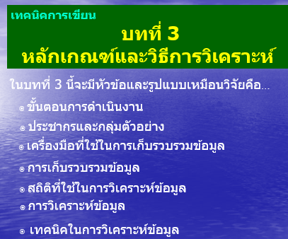
- ขั้นตอนการดำเนินงาน
- ประชากรและกลุ่มตัวอย่าง
- เครื่องมือที่ใช้ในการเก็บรวมรวมข้อมูล
- การเก็บรวบรวมข้อมูล
- สถิติที่ใช้ในการวิเคราะห์ข้อมูล
- การวิเคราะห์ข้อมูลและการนำเสนอ
- เทคนิคที่นำมาใช้การวิเคราะห์

ขั้นตอนการดำเนินงาน
................................................................................................................................
.............................................................................................................................................
............................................................................................................................................. ............................................................................................................................................. .............................................................................................................................................

ประชากรและกลุ่มตัวอย่าง
ประชากร : ได้แก่........... .......................................................................................
.............................................................................................................................................
..................................................................................... จำนวน...............(ระบุ)
ไม่ใช่มนุษย์ เพราะเป็นการวิเคราะห์เอกสาร
กลุ่มตัวอย่าง : ในการวิเคราะห์ครั้งนี้ ใช้ประชากรทั้งหมดเป็นกลุ่มตัวอย่าง
เครื่องมือที่ใช้
................................................................................................................................
.............................................................................................................................................
.............................................................................................................................................
ไม่ใช้แบบสอบถาม เพราะเป็น
การวิเคราะห์เอกสาร
การเก็บรวบรวมข้อมูล
................................................................................................................................
.............................................................................................................................................
.............................................................................................................................................
สถิติที่ใช้ในการวิเคราะห์ข้อมูล
................................................................................................................................
.............................................................................................................................................
.............................................................................................................................................
การวิเคราะห์ข้อมูลและการนำเสนอ
................................................................................................................................
.............................................................................................................................................
.............................................................................................................................................
เทคนิคที่นำมาใช้การวิเคราะห์
................................................................................................................................
.............................................................................................................................................
.............................................................................................................................................

บทที่ 4
ผลการวิเคราะห์
................................................................................................................................
.............................................................................................................................................
............................................................................................................................................. ............................................................................................................................................. .............................................................................................................................................
................................................................................................................................................ .............................................................................................................................................
............ ...................................................................................................
.............................................................................................................................................
............................................................................................................................................. ............................................................................................................................................. ...................................................................................................... .......................................
............................................................................................................................................. .............................................................................................................................................
............................................................................................................................................. ............................................................................................................................................. .......................................................................................................................................
............................................................................................................................................. ............................................................................................................................................. ............................................................................................................................................. ............................................................................................................................................. ................................................................................................................................................
แจกแจงสิ่งที่ค้นพบจากการวิเคราะห์
แป้ง -ไข่-กะทิ-น้ำตาล
และความสัมพันธ์(%)

ตัวอย่าง
วิเคราะห์อัตรากำลัง
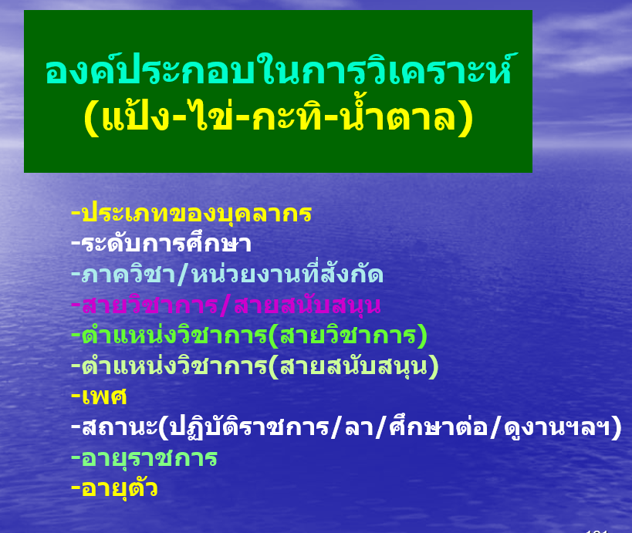
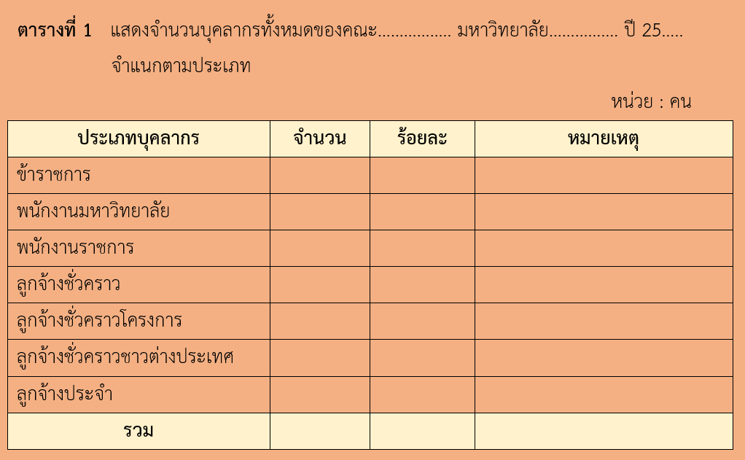
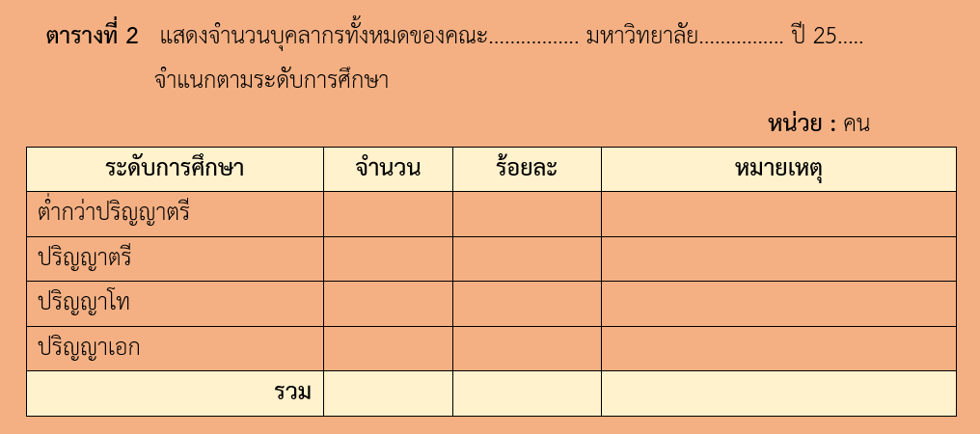
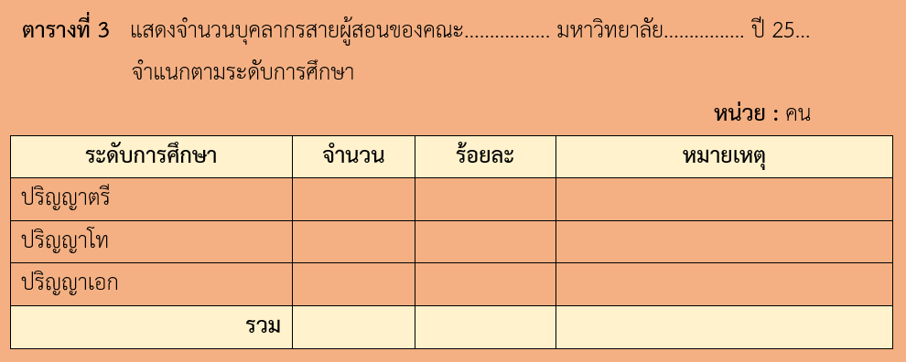
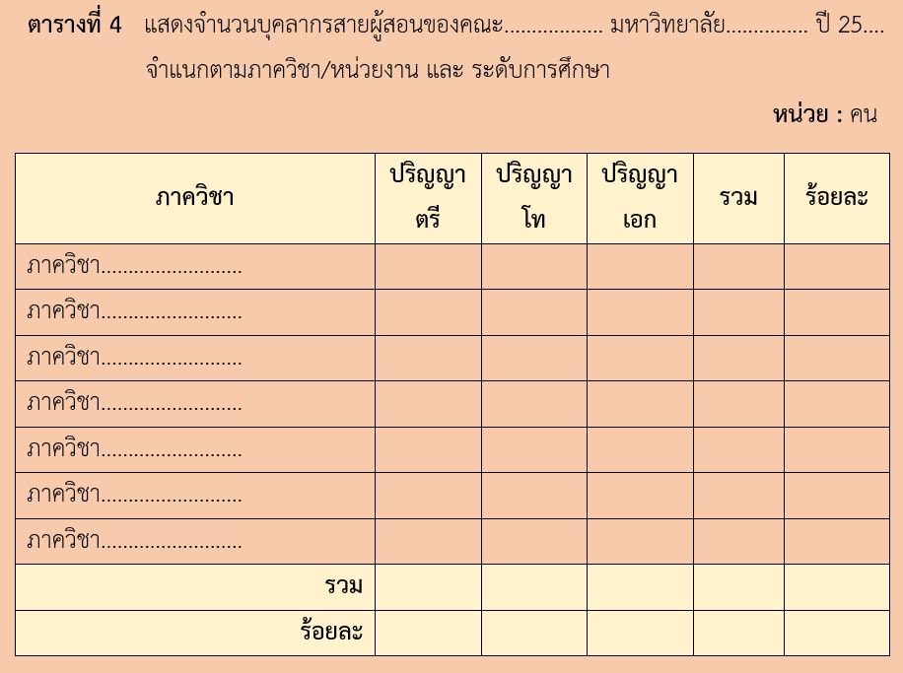
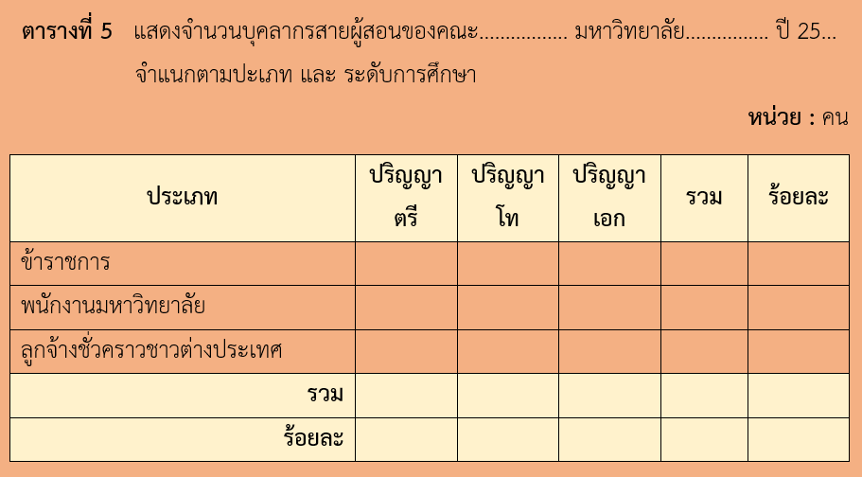
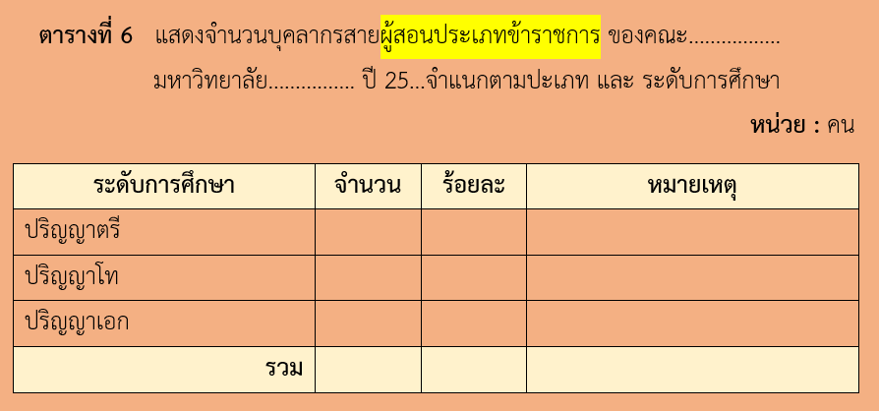
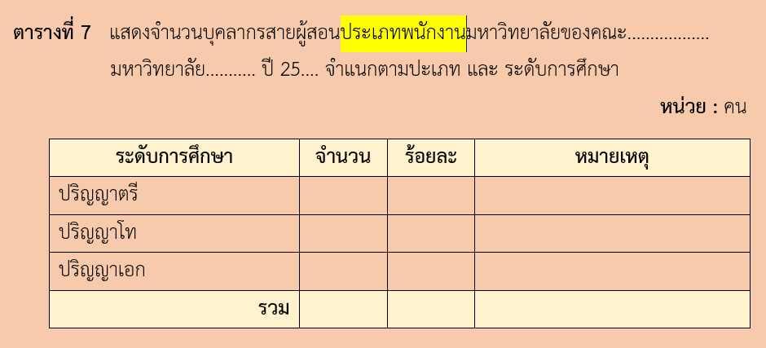
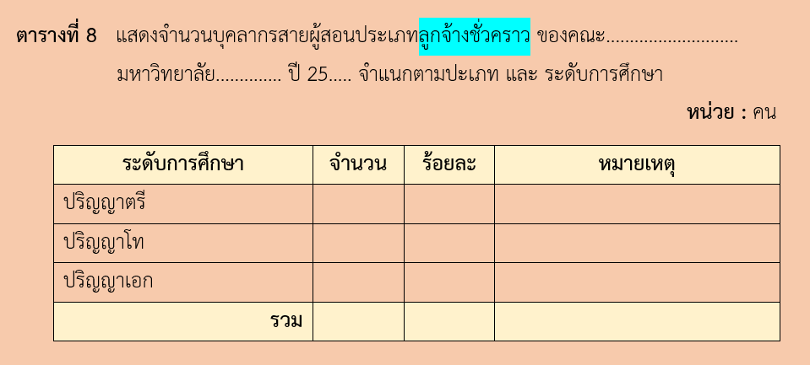
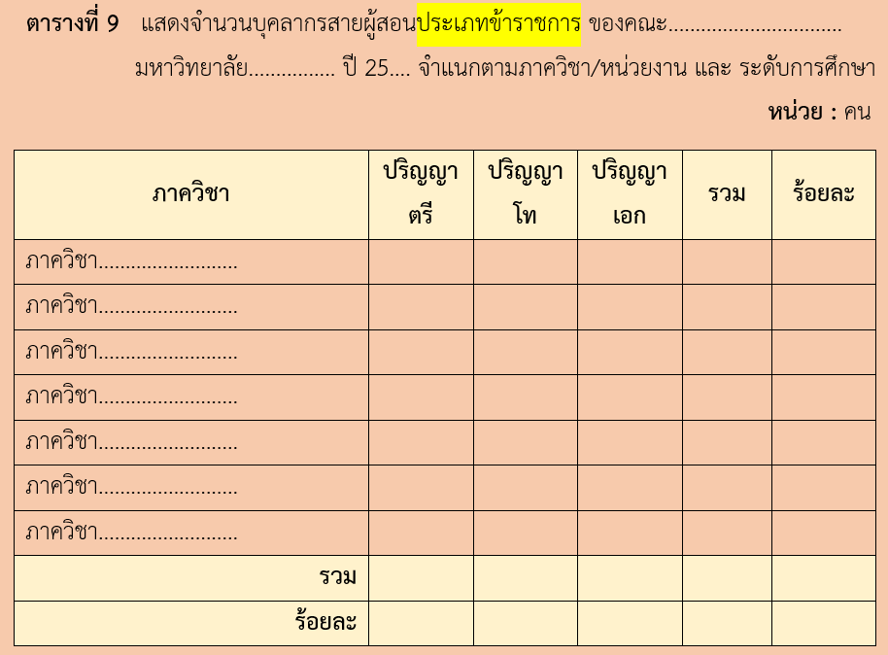
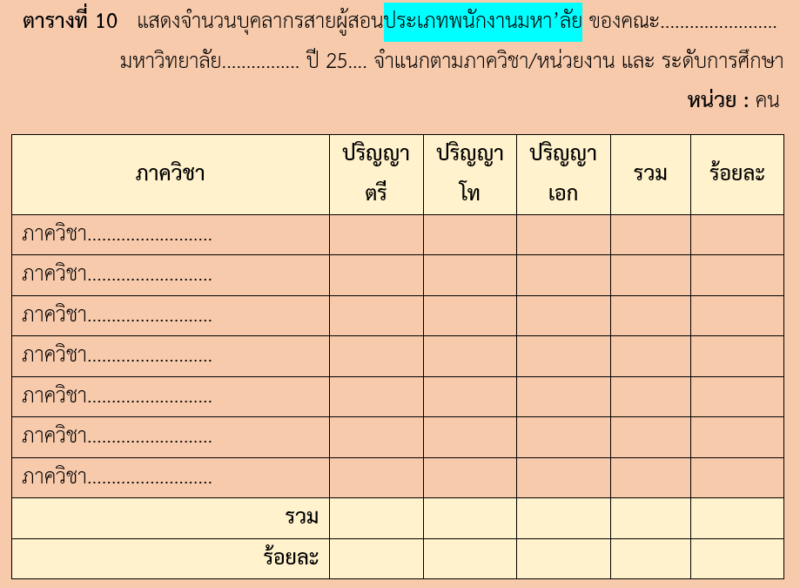
ฯลฯ
บทที่ 5
สรุป และ ข้อเสนอแนะ
สรุปผลการวิเคราะห์
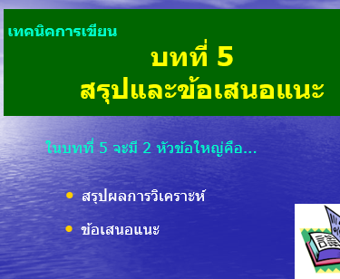
................................................................................................................................
.............................................................................................................................................
............................................................................................................................................. ............................................................................................................................................. .............................................................................................................................................
............................................................................................................................................. .............................................................................................................................................
............ ................................................................................................................................
.............................................................................................................................................
............................................................................................................................................. ............................................................................................................................................. .............................................................................................................................................
ข้อเสนอแนะ
................................................................................................................................
.............................................................................................................................................
............................................................................................................................................. ............................................................................................................................................. .............................................................................................................................................
............................................................................................................................................. .............................................................................................................................................
............ ................................................................................................................................
.............................................................................................................................................
............................................................................................................................................. ............................................................................................................................................. .............................................................................................................................................
............................................................................................................................................. .............................................................................................................................................

*********************************************

บรรณานุกรม
................................................................................................................................................................................................................................................................................................................................................................................................................................................................................................................................................................................

